FEEDBACK REGARDING G&D WEBSITE


The source for the “Companies” news headlines is only from “ABC News Australia”, whereas they should be from various sources as per the Excel spreadsheet:

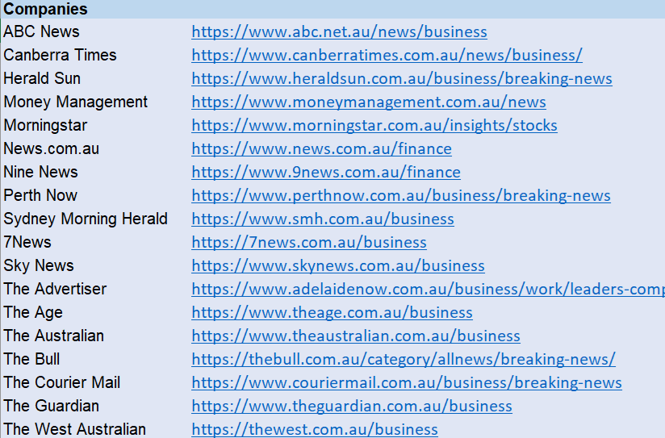

The news headlines are also being duplicated in the other “Latest News” headings.

Also the news headlines should be sourced from the exact webpages shown above - not from their home page which contains too many non-finance articles (remember that our focus is on investing/finance/business/economics/property topics.

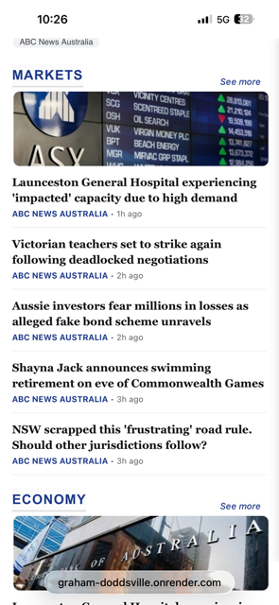
The source for the “Markets” news headlines is only from “ABC News Australia”, whereas they should be from various sources as per the Excel spreadsheet:

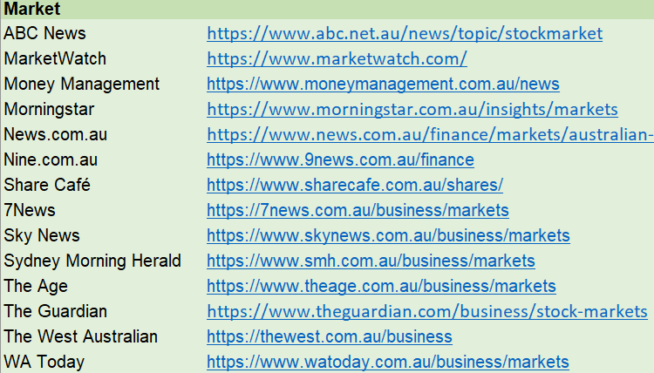

The news headlines are also being duplicated in the other “Latest News” headings.

Also the news headlines should be sourced from the exact webpages shown above - not from their home page which contains too many non-finance articles (remember that our focus is on investing/finance/business/economics/property topics.

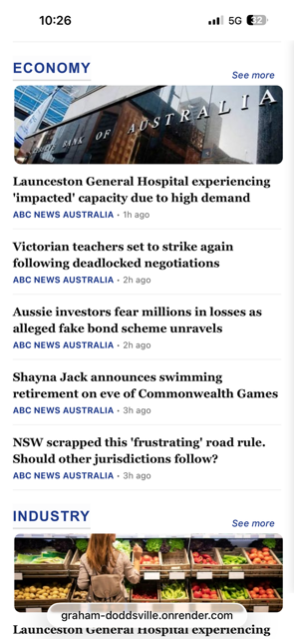
The source for the “Economy” news headlines is only from “ABC News Australia”, whereas they should be from various sources as per the Excel spreadsheet:

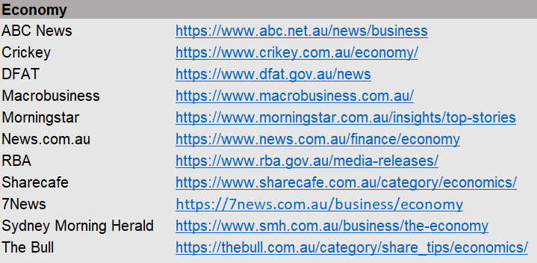

The news headlines are also being duplicated in the other “Latest News” headings.

Also the news headlines should be sourced from the exact webpages shown above - not from their home page which contains too many non-finance articles (remember that our focus is on investing/finance/business/economics/property topics.

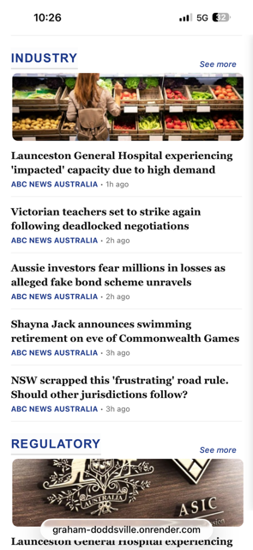
The source for the “Industry” news headlines is only from “ABC News Australia”, whereas they should be from various sources as per the Excel spreadsheet:

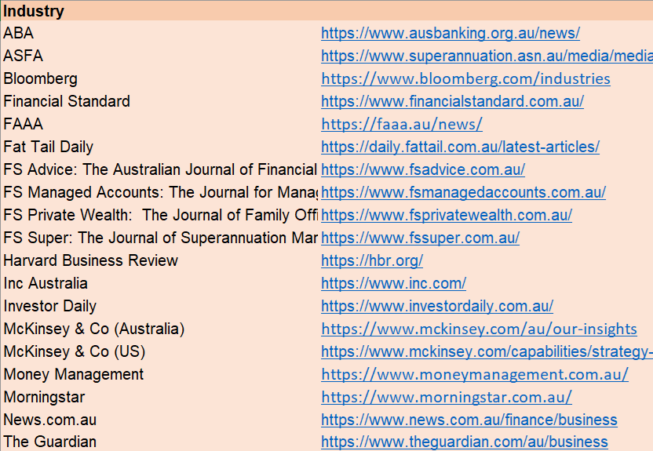

The news headlines are also being duplicated in the other “Latest News” headings.

Also the news headlines should be sourced from the exact webpages shown above - not from their home page which contains too many non-finance articles (remember that our focus is on investing/finance/business/economics/property topics.

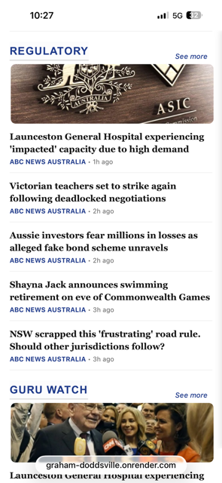
The source for the “Regulatory” news headlines is only from “ABC News Australia”, whereas they should be from various sources as per the Excel spreadsheet:

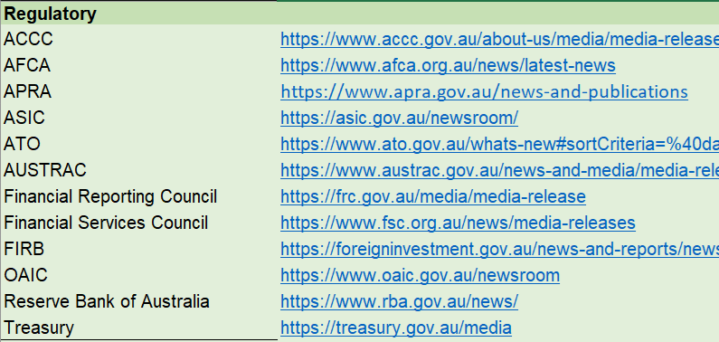

The news headlines are also being duplicated in the other “Latest News” headings.

Also the news headlines should be sourced from the exact webpages shown above - not from their home page which contains too many non-finance articles (remember that our focus is on investing/finance/business/economics/property topics.

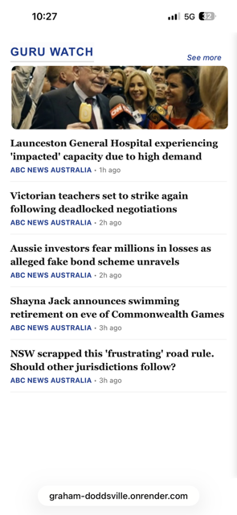
The source for the “Guru Watch” news headlines is only from “ABC News Australia”, whereas they should be from various sources as per the Excel spreadsheet:

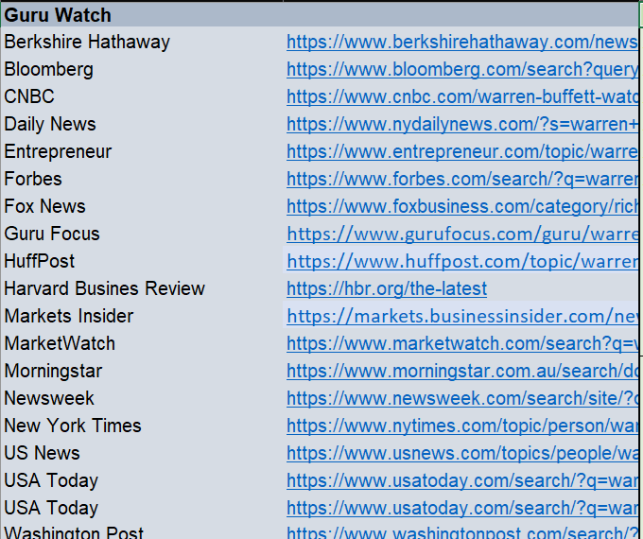

The news headlines are also being duplicated in the other “Latest News” headings.

Also the news headlines should be sourced from the exact webpages shown above - not from their home page which contains too many non-finance articles (remember that our focus is on investing/finance/business/economics/property topics.

For the “Asia” news headlines, there are too many “India” sources – one is enough. News headlines should also be sourced from the following:

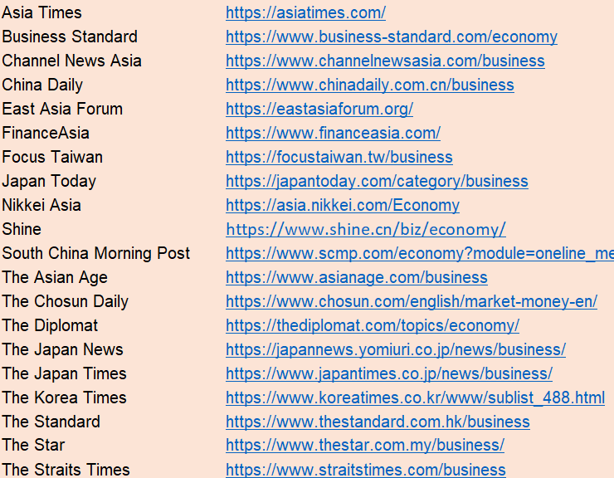

Also the news headlines should be sourced from the exact webpages shown above - not from their home page which contains too many non-finance articles (remember that our focus is on investing/finance/business/economics/property topics.

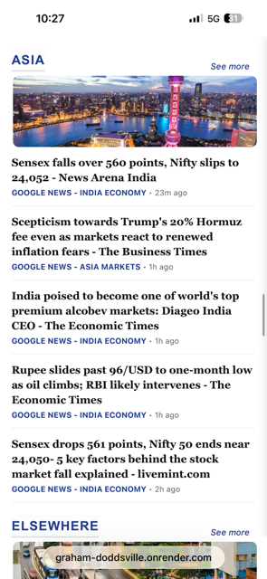


What you’ve done here looks amazing! I really like it. Unfortunately, for legal reasons, we are not permitted to use their imagery and the by-lines. We can only use the news headlines, source name and date of publication. So please change this accordingly.

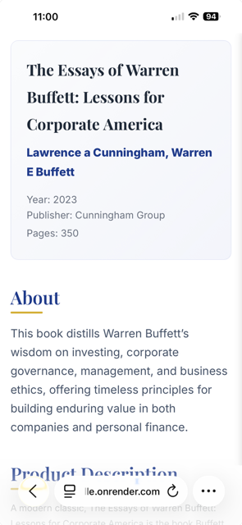
The book summaries need to display the book covers (image). I’m not sure how you want to display it but maybe somewhere after “Pages” and before “About”

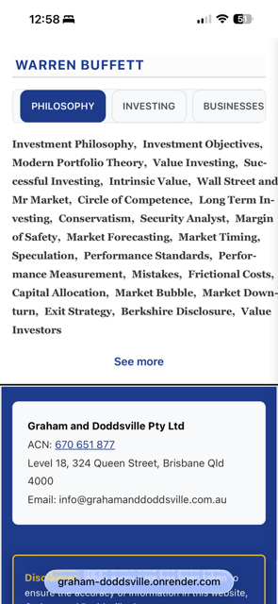
Change this heading to “WARREN BUFFETT QUOTES”

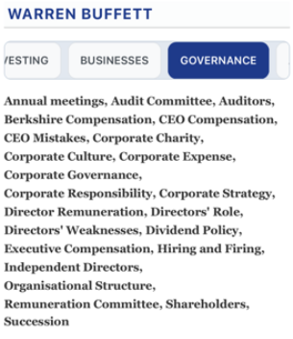
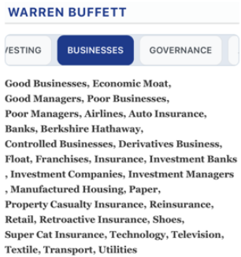
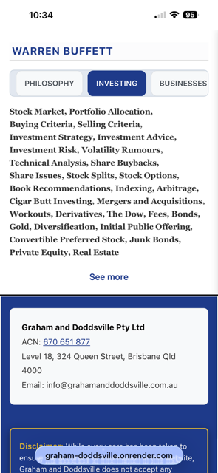
Why are these blank spaces – ie. why don’t the words below move up one line?

Do the same for the “Business”, “Governance” and “Accounting” tabs
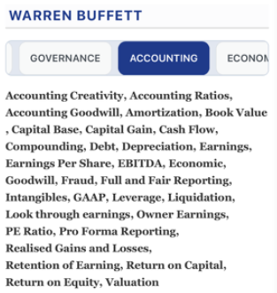
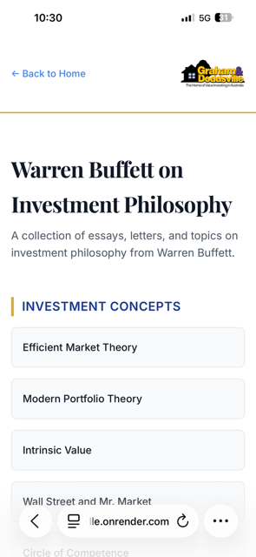
The secondary pages of “Warren Buffett Quotes” do not show the correct categories or are displayed in the wrong order.

For “Warren Buffett on Investment Philosophy”, the subtitle should be

A collection of Warren Buffett’s insightful quotes on investment philosophy, principles and rational thinking.

Then, the categories displayed should be as follows (in this order):

Investment Philosophy, Investment Objectives, Modern Portfolio Theory, Value Investing, Successful Investing, Intrinsic Value, Wall Street and Mr Market, Circle of Competence, Long Term Investing, Conservatism, Security Analyst, Margin of Safety, Market Forecasting, Market Timing, Speculation, Performance Standards, Performance Measurement, Mistakes, Frictional Costs, Capital Allocation, Market Bubble, Market Downturn, Exit Strategy, Berkshire Disclosure, Value Investors

Finally, the format of each page should not be pop-up style (refer to my email on 14 July 2026).

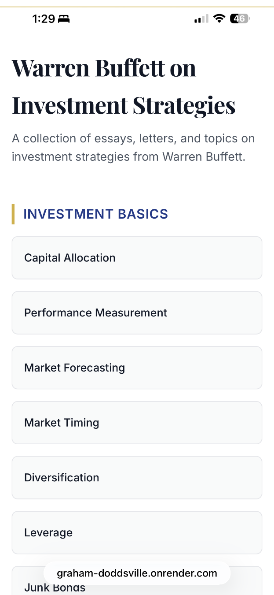
The secondary pages of “Warren Buffett Quotes” do not show the correct categories or are displayed in the wrong order.

For “Warren Buffett on Investment Strategies”, the subtitle should be

A collection of Warren Buffett’s insightful quotes on stock market investing, portfolio construction and corporate actions.

Then, the categories displayed should be as follows (in this order):

Stock Market, Portfolio Allocation, Buying Criteria, Selling Criteria, Investment Strategy, Investment Advice, Investment Risk, Volatility Rumours, Technical Analysis, Share Buybacks, Share Issues, Stock Splits, Stock Options, Book Recommendations, Indexing, Arbitrage, Cigar Butt Investing, Mergers and Acquisitions, Workouts, Derivatives, The Dow, Fees, Bonds, Gold, Diversification, Initial Public Offering, Convertible Preferred Stock, Junk Bonds, Private Equity, Real Estate

Finally, the format of each page should not be pop-up style (refer to my email on 14 July 2026).
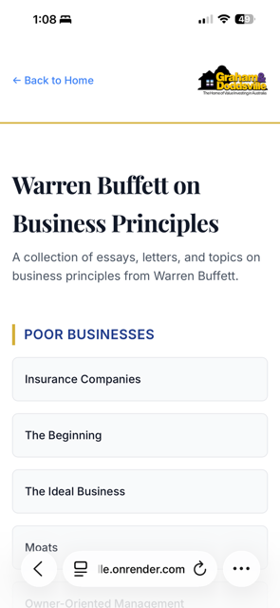
The secondary pages of “Warren Buffett Quotes” do not show the correct categories or are displayed in the wrong order.

For “Warren Buffett on Business Principles”, the title should just be “Warren Buffett on Businesses”

Then the subtitle should be

“A collection of Warren Buffett’s insightful quotes on good and bad businesses and the managers that operate them.

Also, the categories displayed should be as follows (in this order):

Good Businesses, Economic Moat, Good Managers, Poor Businesses, Poor Managers, Airlines, Auto Insurance, Banks, Berkshire Hathaway, Controlled Businesses, Derivatives Business, Float, Franchises, Insurance, Investment Banks, Investment Companies, Investment Managers, Manufactured Housing, Paper, Property Casualty Insurance, Reinsurance, Retail, Retroactive Insurance, Shoes, Super Cat Insurance, Technology, Television, Textile, Transport, Utilities

Finally, the format of each page should not be pop-up style (refer to my email on 14 July 2026).
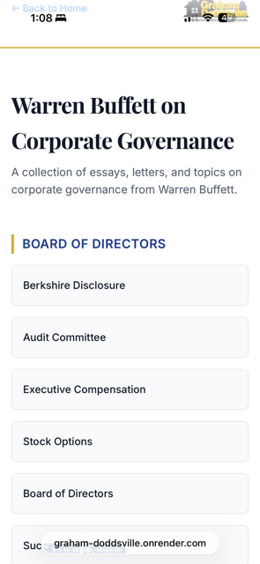
The secondary pages of “Warren Buffett Quotes” do not show the correct categories or are displayed in the wrong order.

For “Warren Buffett on Corporate Governance”, the subtitle should be

A collection of Warren Buffett’s insightful quotes on directors, management and the realities of corporate governance

Also, the categories displayed should be as follows (in this order):

Annual meetings, Audit Committee, Auditors, Berkshire Compensation, CEO Compensation, CEO Mistakes, Corporate Charity, Corporate Culture, Corporate Expense, Corporate Governance, Corporate Responsibility, Corporate Strategy, Director Remuneration, Directors' Role, Directors' Weaknesses , Dividend Policy, Executive Compensation, Hiring and Firing, Independent Directors, Organisational Structure, Remuneration Committee, Shareholders, Succession

Finally, the format of each page should not be pop-up style (refer to my email on 14 July 2026).

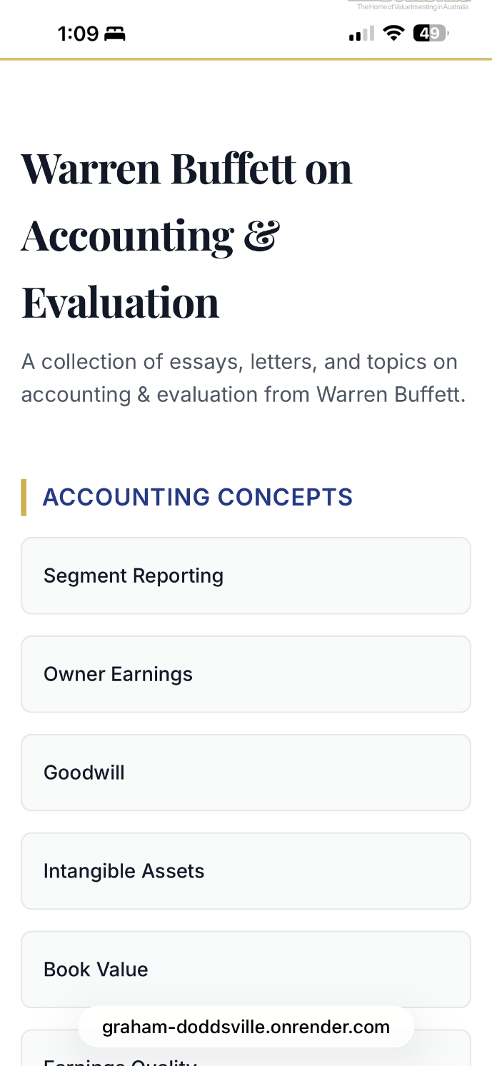
The secondary pages of “Warren Buffett Quotes” do not show the correct categories or are displayed in the wrong order.

For “Warren Buffett on Accounting and Evaluation”, the topic should be changed to “Warren Buffett on Accounting and Valuation”

Then the subtitle should be

A collection of Warren Buffett’s insightful quotes on accounting creativity, valuation and various accounting concepts

Also, the categories displayed should be as follows (in this order):

Accounting Creativity, Accounting Ratios, Accounting Goodwill, Amortization, Book Value, Capital Base, Capital Gain, Cash Flow, Compounding, Debt, Depreciation, Earnings, Earnings Per Share, EBITDA, Economic, Goodwill, Fraud, Full and Fair Reporting, Intangibles, GAAP, Leverage, Liquidation, Look through earnings, Owner Earnings, PE Ratio, Pro Forma Reporting, Realised Gains and Losses, Retention of Earning, Return on Capital, Return on Equity, Valuation

Finally, the format of each page should not be pop-up style (refer to my email on 14 July 2026).

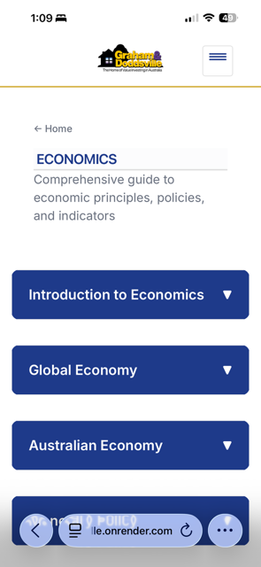
For “Warren Buffett on Economy”, the secondary page is incorrect. It should be the same as the other secondary pages (above).

The subtitle should be:

A collection of Warren Buffett’s insightful quotes on inflation, international trade and the domestic and global economy

Also, the categories displayed should be as follows (in this order):

Budget Deficit, Currency, Globalisation, Global Economy, Gross Domestic Product, Inflation, Interest Rates, International Trade, Macroeconomics, Recession, Trade Imbalance, US Economy

Finally, the format of each page should not be pop-up style (refer to my email on 14 July 2026).

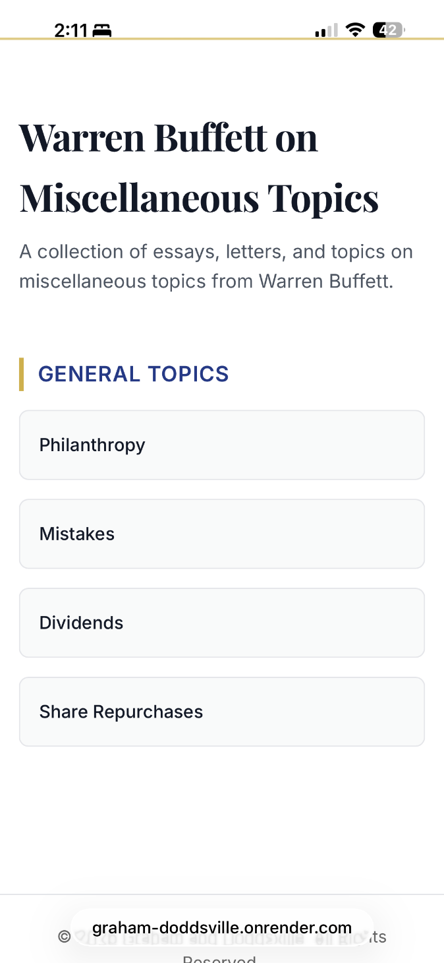
The secondary pages of “Warren Buffett Quotes” do not show the correct categories or are displayed in the wrong order.

For “Warren Buffett on Miscellaneous”
the subtitle should be:

A collection of Warren Buffett’s insightful quotes on miscellaneous topics ranging from love and happiness to philanthropy and success.

Also, the categories displayed should be as follows (in this order):

Benjamin Graham, Character, Charlie Munger, David Dodd, Happiness, Love, Partnership, Philanthropy, Public Pension, Success, Taxation, Unconventional Commitments

Finally, the format of each page should not be pop-up style (refer to my email on 14 July 2026).

